**IA4580 Project Milestone 1: Project Requirements analysis and planning**

**Executive Project Summary**

**Problem statement**

One of the major issues we have noticed in existing restaurant ordering applications is security concerns. Customers wants there data to be remained secure while they order food from a restaurant. This is the main motivation for this project, using Paypal Payment Gateway the customers will easily make orders in a reliable way.

**Goals:**

Our goal is to provide users a secure and reliable restaurant ordering app that can entertain 1000s of users at a time without crashing or losing its performance. Hence, secure restaurant ordering app aims to increase customer satisfaction up to 90% in first 3 months. On the other hand, the complete tested project will be delivered in 4 months after the contract sign.

**Merit of the project**

The most important asset of any business organization is their customers, so we want our customers to have trust on this application in terms of security and safety of their confidential data. In online applications customers wants their credit card information to be highly secured and hack proof. To gain the long term benefits and customer satisfaction our main focused will be the software architecture that need to hack proof by using appropriate software architectural styles.

**• Proposed project timeline - When will you do it?**

* Define the tasks and expected time to completion

|  |  |
| --- | --- |
| Task Name | Duration |
| **Project Management** | **9 days** |
| PM Plan | 1 day |
| Scope statement | 1 day |
| Schedule | 2 days |
| Risk Plan | 3 days |
| Change plan | 2 days |
| Meeting Schedule | 1 day |
| **Requirements** | **8 days** |
| Prototype User Interface | 5 days |
| Manage changing requirements | 3 days |
| **Refine System Definition** | **8 days** |
| Use cases | 3 days |
| Domain Diagram | 2 days |
| Class Diagram | 3 days |
| **Architectural Definition** | **10 days** |
| Define basic Software architecture | 1 day |
| Finalize architecture | 2 days |
| Detailed Design submission | 7 days |
| **Development Components** | **7 days** |
| GUI development | 6 days |
| CRUD Menu | 3 days |
| Order Food | 3 days |
| Pay Bill | 2 days |
| Implement GPS | 2 days |
| Photo Gallery with Picasa, Flickr | 2 days |
| Coupon feature | 2 days |
| Event Calendar for Special evenings | 3 days |
| **Testing** | **15 days** |
| Unit testing | 5 days |
| Integration and testing | 6 days |
| Acceptance Testing | 4 days |

* **Create and submit a gantt chart**

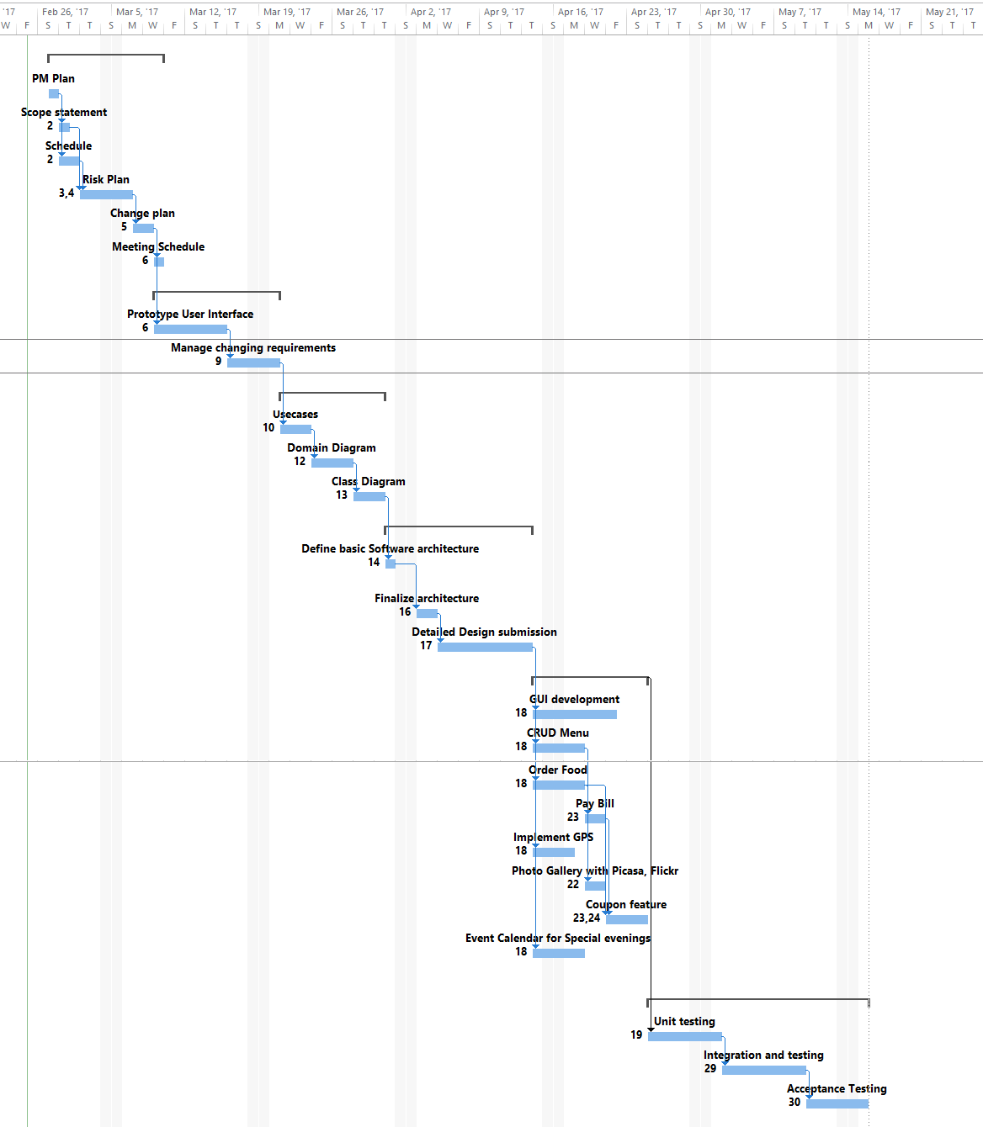

**• Project-oriented risk list - What could go wrong in the project and why?**

|  |  |  |  |
| --- | --- | --- | --- |
| Risk Name | Impact | Likelihood | Description |
| Project management | 3 | 2 | Project manager is to able to follow schedule and achieve mile stones |
| Poor security implementation | 5 | 4 | Bad Architect – Unable to implement security |
| Tool License Expiry | 3 | 2 | Tool expired during development and its cost is not factored in budget |
| Application design | 4 | 4 | The design was not reviewed well by the architect |
| Design Issues | 4 | 3 | Some design flaws remain unnoticed |
| Poor cost estimation | 4 | 3 | In terms of man hours or resources. |

**• Application requirements - What does your app/product do?**

* **User stories**
  + As a user, I can order food in minimum steps.
  + As a user, I can securely pay my order bill.
  + As a manager, I can update Menu frequently without disturbing in process customer’s orders.
  + As a user, I can locate nearest restaurant.
* **Use cases**

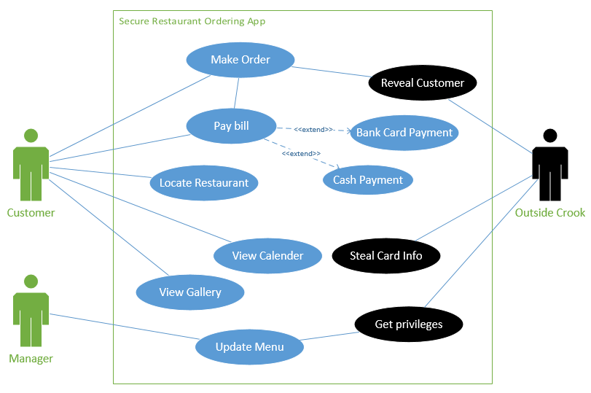

**• Resources/Technology needed - What do you need to be successful?**

|  |  |  |  |
| --- | --- | --- | --- |
| Resource | Dr. Hale needed? | Investigating Team member | Description |
| ****MS Visual Studio**** | No | Yaqoob Al Farsi | Required for software design and architect |
| MS Project management | Yes | Yaqoob Al Farsi | Monitor and control schedule and resources |
| Android Latest Version | No | Yaqoob Al Farsi | For programming |
| Android Phone | No | Alsalt Alkharusi | Testing purpose |
| Tablet PC | No | Alsalt Alkharusi | Testing purpose |
| Designing tool | No | Alsalt Alkharusi | GUI development |

**• First Sprint Plan - Create the first plan on trello**

**• Note about Teamwork and Group projects**

|  |  |
| --- | --- |
| **Tasks** | **Team Member Involved** |
| Contribution to the github repo | **Alsalt Alkharusi, Yaqoob Al Farsi** |
| Activity in the slack channel for your project | **Alsalt Alkharusi** |
| Activity on Trello | **Yaqoob Al Farsi, Alsalt Alkharusi** |
| Team evaluations | **Alsalt Alkharusi** |